使用520编码电机（装甲车的电机）

[商品详情](https://item.taobao.com/item.htm?spm=a1z09.2.0.0.30052e8d0C3GmX&id=777749965619&_u=4202c3prc37a52&pisk=g_6L6d9HJP43Zj90KJNMqGaR2pqgsTIFbwSjEUYnNNQOyinhtQYkNLQVkQMuTpAJeNTGKejHd3O5rZ1HR6YoeTQNJvDkda2JPi5a4exhK0K51wHltMYh60pFI6Dk-yJRVZv8or20nMSeQLa0oWf3g0pX4bGIrUssCLxRsMGncMSeUUa0o-2cY4IEjf3WVUZ9C3KxdLOBORG6733WVaTB1Vtv0LT5Pa9sfnxyPXGBFhG67nuIRvT7CRtvDbtIOas_X3xJFUGxWXLraUMRMGFFROk9rYM5BHd_sMT__a66vtYAABkEL0-p9EsBWrb-3xR14QBr4YdfAs7ycwgQyUWOf91flPcHRsKRm_IQdA9hLM1XNtarNZpdyI6B60MfYMTHBh6bqj8GBeb5pCZmHQv1nI9Cs5zHZpKAP97K2Y_fjiXe_TUx5U5H0dtRUoGJyQsrNtXxm7uDk3cQXlhraBtwrMWe9BF9JEt9oljiabRgGhL0XlhraBtwXEqMSblysS1..)

使用三种分板，进行钢柱或者引脚钢针堆叠

[【Omni B系列/P系列】金属全向轮58mm智能车轮omni Robot 60 75mm-淘宝网](https://item.taobao.com/item.htm?_u=4202c3prc3c436&id=665727652632&pisk=glsSzXArVbc7KKlcE7e21HL6v_KCO6Zavv9dI9nrp3KJRDBP1poe8zvIAI6TEQz3r6_f9sYywB8eAp1wiToUETyQA9B9wH7yapCVOs0PaMRFgk6G1UoPpMklo1Wt4gzkYDtkxHFa_lraETxHv8WPSMlkMdp8Y0pJy3xx_QMzWlrNEtMyeRWYbgkdwDJZJDCpyEnvpInKy0CpknpkM0pK2phYhpAvvLnpeIBvQLOKvpCKkqpwIphJpLLxkppevBCpv-6xgBqX3JR5F8Md8KQElc6yGDndcKFHGTwjYKsWFCA1eU0moJvWPCBJG55IjcYAKesnKDTOeNfHB_h8OBjfHgQO6SuywN9CQw682mKPqTQ9JGFnJ1t5OFIJlvnOETdycKITLVAVcQ5dVEeZfe-AbFKRurVy83919gfSdDCO3OSkoMNsMBbyInpCxR3BOeIPScR_y43IhFmBhCybh20Hj6olB3vQYxLJnKlah-GWDUpDhCybh20HyKv4Q-wjNnC..&spm=a1z09.2.0.0.30052e8d0C3GmX)

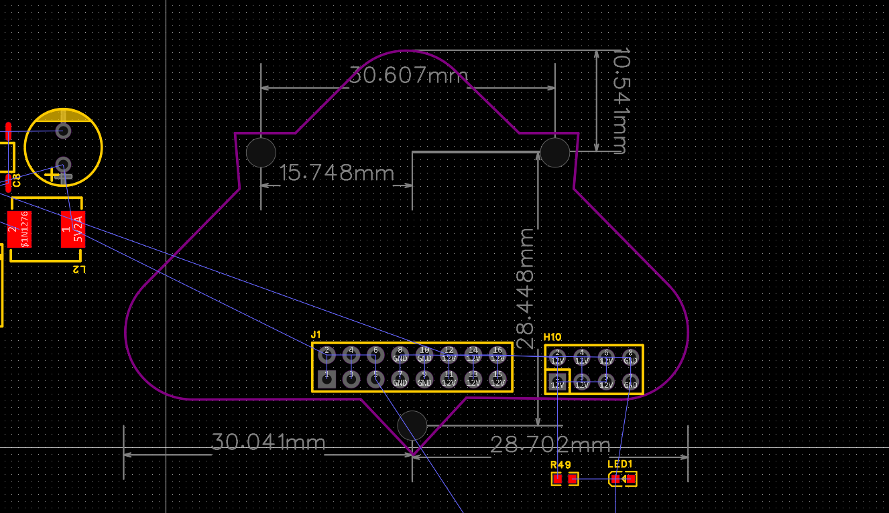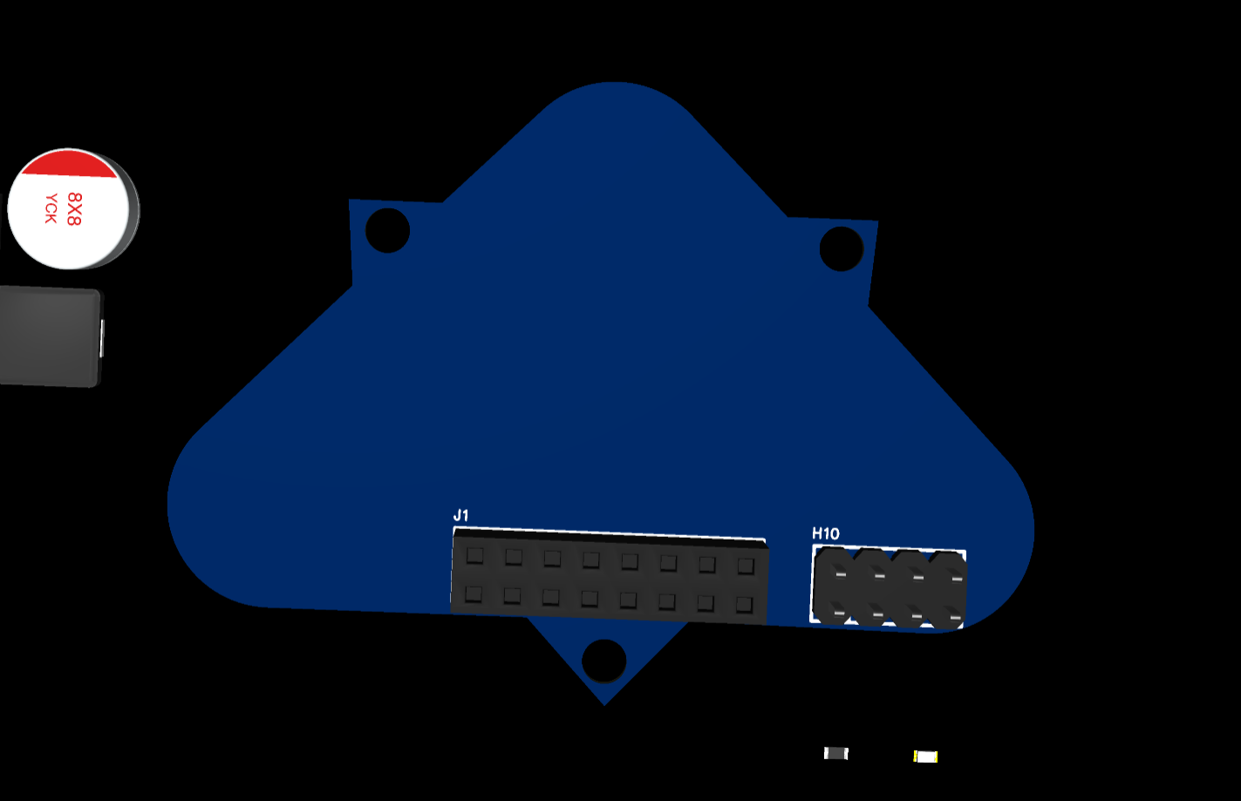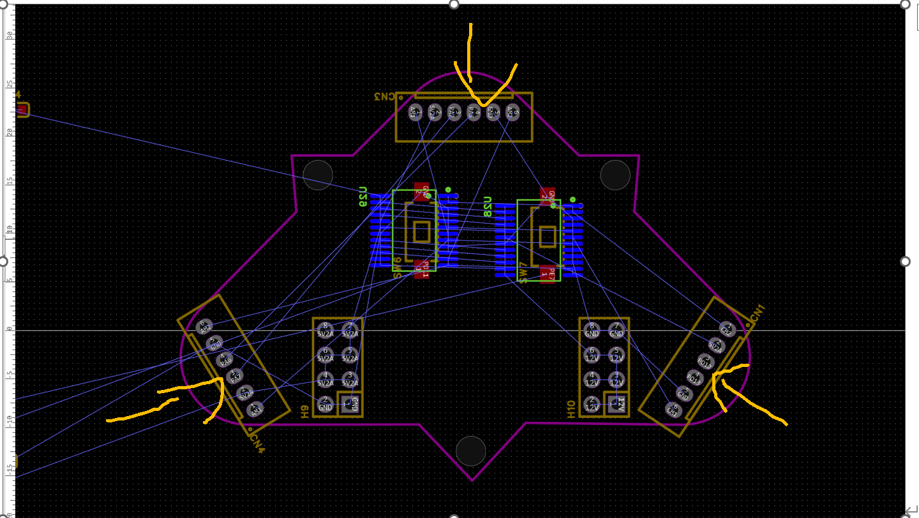橙色为电机线插入口方向